ANNUAL DEGREE PROGRAM ASSESSMENT REPORT

Overview
The emphasis of the report should be on PLO and CASLO assessment, action items emerging from those assessments, and a table listing the top three budget requests from each degree program. Bullet points are certainly acceptable for the sections requiring written responses. Finally, if you respond to the system data please keep each section (demand, effectiveness and efficiency) to 100 words or fewer. Refer to the ARPD Instructions when you upload your report elements to the system website. The roman numerals indicate the corresponding system item number for when you upload your report to the UH System website.
http://www.hawaii.edu/offices/cc/arpd/instructional.php?year=2015&action=quantitativeindicators&college=HAW
Select Maui College and your program in the drop down menus.
On the page that shows the Quantitative indicators, click on “web submission”. You will log in to get to your program submission pages.

Remember to click on “save” icon for EACH SECTION.

See the end of this document for more assistance with web submission.

2016-17 Program Review preparation guidelines

Program Name: Early Childhood Education (ECED)
DESCRIPTION TAB
Program Description
The Early Childhood Education program is designed to prepare students to work with young children from birth to 5 and their families.
The curriculum is organized around a core of courses that provide skills and knowledge needed by early childhood educators. Students earn an Associate in Science (AS) degree in Early Childhood Education that articulates into the UH West Oahu’s Bachelor’s in Social Science degree, Early Childhood Education concentration.
UH Community College’s Early Childhood Education (ECED) program mission:
· Provide training and education programs for the development of competent and nurturing caregivers and teachers for all Hawai‘i’s young children and their families.

UHMC’s Early Childhood Education program mission:
· The Early Childhood Education program prepares students to work in a variety of early childhood programs (serving children birth to age eight). Courses in the program allow students to build the attitude, skills, and knowledge needed to be an effective early childhood teacher.

- Briefly respond for each cautionary and/or unhealthy Quantitative Indicator (II):
  - Demand Indicator: Cautionary due to number of majors (61) and prorated county replacement positions (8).

  - Effectiveness Indicator: Healthy

  - Efficiency Indicator: Healthy

ANALYSIS TAB
- Analysis of the Program
  - Briefly discuss any new significant program actions (new certificates, stopout, gain or loss of positions) as results of last year’s action plan.
    - Second annual report for NAEYC (National Association for Education of Young Children) Associate Degree accreditation submitted Sept. 30, 2017. This report included all six revised key assessments.
  - If relevant, share a brief analysis for any Perkins Core Indicator not met.
    - 2P1 – Completion – not met. Goal is 51%, actual was 25%. Completion is counted when student stops out after certificate or degree attainment. 3P1 – Retention or transfer rate, was 100%, so all students either stayed on or transferred.
    - 5P1 and 5P2 – Nontraditional participation and transfer, were both not met. Lack of males in early childhood education is an issue across the nation. Fall 2017 semester – five males enrolled in ECED courses.
- Goals and/or actions from previous assessment results
- Describe results from previous assessment goal and/or action implementation

  - PLO
All key assessments for accreditation were revised and implemented, Sept. 2017 annual report included data on all the NAEYC standards (which are aligned with ECED PLOs).
Still need to work on conceptual framework to make it student friendly.

  - CASLO
Oral communication was the domain this year. ECED advisory likes to discuss education issues, and we allotted just 30 minutes, feedback included comment that more time was needed. Members generally agreed that COM 145 (Interpersonal Communication) addresses more of what early childhood educators need than SP 151 (Personal and Public Speech). However, students going on to UH West O’ahu need SP 151. Recommendations included seeing if UHWO would accept COM 145. Program Coordinator will start inquiring with UHWO faculty as to whether this would be feasible.
P-SLOs TAB
- PLO selected for assessment (click on the PLO assessed – it will turn green).
All PLOs were assessed via accreditation key assessments.
For this report, PLO 7: Advocate for children and their families within the program. (NAEYC Standard 6e: Engaging in informed advocacy for young children and early childhood profession.)

- Industry Validation (check all that apply):

Advisory Committee Meeting(s) X, How many? _1_
Did Advisory Committee discuss CASLO/PLO? Yes_X_ No__
Coop Ed Placements __ Fund raising activities/events __ Service Learning X – students have SL option in several courses
Provide program services that support campus and/or community UHMC/MEO Head Start partnership
Outreach to public schools __
Partner with other colleges, states and/or countries _X_ ECED Program Coordinating Council for UHCCs, Kaulanakilohana (higher ed faculty group – UH system and Chaminade University)
Partner with businesses and organizations _X_ Pūnana Leo o Maui, PATCH
Other__ Describe_______________________________________________________________

- Expected level of Achievement:
For the PLO assessed, 50 % of students completing the assignment/course expected to meet expectations for the assignment/course.
- This is a low percentage that needs improvement. This reflects the ongoing need to improve on giving information and opportunity to apply knowledge of Family Partnership Guidelines, E Mālama i Nā Keiki – Essential Principles of Practice for Hawai’i's Early Childhood Professional, resources for families, and advocacy. It is very clear that more time in class needs to be spent on the information and application related to the standards.
- More checks throughout the semester will be done in class on the assignment. Students will be given opportunity to work on case studies, information on community resources will be shared, and more in-depth information about different types of advocacy will be covered in Fall 2017.

- Courses (or assignments) Assessed:
Key assessment 2in ECED 245/FAMR 235 (Child, Family, Community) – Families and Educator interviews and analysis

- Assessment strategy/Instrument/Evidence (check all that apply):
Work Sample__ Portfolio__ Project __ Exam __ Writing Sample __
Other__ Please explain__This key assessment looks at several standards. Students interview two families with diverse characteristics and one early childhood educator. They then analyze the interview using two documents, Family Partnership Guidelines (Executive Office on Early Learning) and E Mālama i Na Keiki – Essential Principles of Practice for Hawai’i's Early Childhood Professionals (Hawai'i Careers with Young Children)____

- Results of program assessment:
  - The following were present at the PLO assessment:
Program coordinator and program faculty, report submitted to National Association for Education of Young Children, Higher Education Accreditation.
  - Strengths and weaknesses (best practices and educational gaps) found from PLO assessment analysis .
See comments in #3.
- Other comments:
Describe CASLO assessment findings and resulting action plans. Go to Laulima UHMC CASLO Assessment for your program’s “Assessment results” and summarize below.

CASLO assessment findings | Action plan to address findings
Discussion was held at annual Advisory Committee meeting. Participants’ consensus was that COM 145 (Interpersonal Communication) is a course that is more relevant to the workplace than SP 151 (Personal and Public Speech). However, UH West O’ahu requires SP 151, so students intending on transferring take SP 151. | Participants suggested working with UHWO to change the requirement from SP 151 to COM 145. Program coordinator will consult with UHWO faculty to see if this is possible.

- Next steps:
For program learning outcomes (check all that apply):
Assess the next PLO___ Review PLOs___ Adjust assignment used for PLO___
Adjust course used for PLO___ Meet with Advisory Committee____
Other___ Please explain: Will continue to gather data on the six key assessments and use the data for program improvement. Full accreditation report is available on request.

- Please list any professional development needs you may have for your program.
Annual NAEYC Professional Learning Institute (PLI) is a national conference that provides a variety of professional development opportunities. Program Coordinator and FT faculty attend using personal funds, access to some funding from college would be appreciated.

System website:
http://www.hawaii.edu/offices/cc/arpd/instructional.php?year=2015&action=quantitativeindicators&college=HAW
Select Maui College and your program in the drop down menus.
On the page that shows the Quantitative indicators, click on “web submission”.
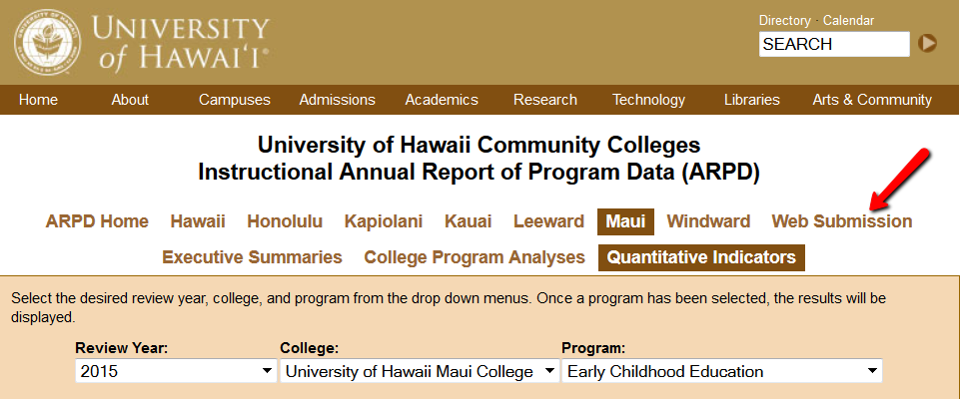

You’ll log in on the next page.
When the page with tabs comes up, click on Analysis tab.
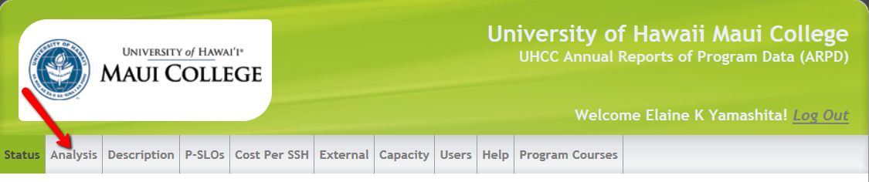

Click on “edit”. Copy and paste from this document into each section. If you are pasting from Word, you need to click on the “W” icon and then paste into the box that pops up (like in Laulima). See green arrow below.
REMEMBER TO “SAVE” EACH SECTION! (red arrow in pic below).

You’ll be entering information into:
- Analysis
- Description
- P-SLOs
- External (if your program has an external exam)

REMEMBER TO SAVE (red arrow) EACH SECTION!
